IPGS-5506
Industrial Unmanaged GbE PoE+ Switch

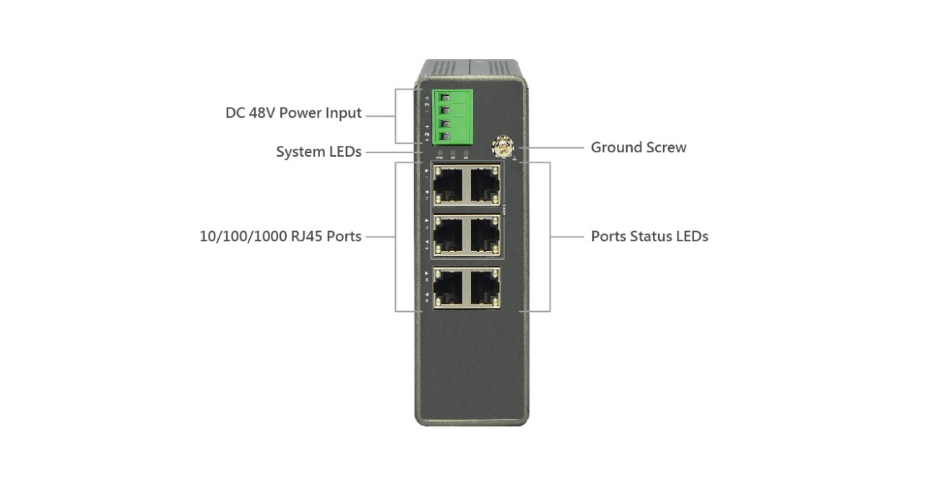

Overview
IPGS-5506 industrial unmanaged GbE PoE+ switch is a plug-and-play Ethernet switches offering easy way to make the transition to Gigabit Ethernet and increase the speed of your network connection. The energy efficient, built to last, and rigorously tested provide the reliability businesses need, of which make them suitable for industrial Ethernet applications.
IPGS-5506 delivers 6 (10M/100M/1G) RJ45 with 4 PoE+ (Support 802.3 at/af, and total up to 120W) ports. IPGS-5506 offers users with various options of port combinations and PoE+ budget, in order to meet different requirements in various applications.
Key Features
- Slim type industrial switch
- IEEE 802.3af/at Power over Ethernet
- IEEE 802.3az Energy Efficient Ethernet standard for green Ethernet application

Benefits
- Lowing Total Cost of Ownership (TCO) with Energy-efficient Design
The switch is designed to help companies to save power needs and reduce TCO by Energy Efficient Ethernet (IEEE 802.3az). It can be used for customers to build a green Ethernet networking environment.
Specifications
Port Configuration
Total Ports | RJ45 (10M/100M/1G) | Uplinks (100M/1G) | Console
6 | 6 | -- | --

Hardware Performance
Forwarding  Capacity (Mpps) | Switching  Capacity (Gbps) | Mac Table  (K) | Jumbo Frames  (Bytes)
8.928 | 12 | 4 | 9216

Environmental Range
Operating Temperature |  | Storage Temperature |  | Operating Humidity | Altitude
Fahrenheit | Centigrade | Fahrenheit | Centigrade | 5% to 95%  non-condensing | Feet | Meters
-40 to 167 | -40 to 75 | -40 to 185 | -40 to 85 |  | <10000 | <3000

Dimension, Weights, Mounting
Dimension (WxHxD) |  |  | Weight |  |  | Mounting Type
Millimeter | Inches |  | Kilograms |  | Pounds
44x 135x 130 | 1.7x 5.3x 5.1 | < 1 |  | <2.2 |  | DIN rail, Wall

Voltage and Frequency
Primary Power Supply - DC Input Voltage
DC Nominal | 48 VDC inputs  12/24/48 VDC for PoE mode (by request)
DC Operating Range | 48 to 57 VDC for PoE function and 51 to 57 VDC for PoE AT mode

PoE Power Capacity
Available PoE Power | Number of Ports That Support PoE(15.4W), PoE+(30.0W)
120W | Each of port 1 - 4 support PoE/ PoE+ within available PoE Power

Certifications
Regulatory Compliance
EMS | EN61000-4-2 ESD, EN61000-4-3 RS, EN61000-4-4 EFT, EN61000-4-6 CS, EN61000-4-8 PFMF, (EN61000-6-2 by request)
EMI | FCC Part 15 Class A  (EN61000-3-2, EN61000-3-3, EN61000-6-4, EN55022, EN55011 by request)
Safety | CE, (EN60950 by request)
Mechanical Stability (by request)
Vibration | IEC 60068-2-6
Shock | IEC 60068-2-27
Freefall | IEC 60068-2-32
Approvals (by request)
Railway Norm | EN50121-4, EN50155
Transportation | NEMA TS2
Substation | IEC61850-3, IEEE1613

